Fomrhi Comm 1957 David van Ooijen

A Japanese vihuela spotted in China; a footnote to Comm 1955

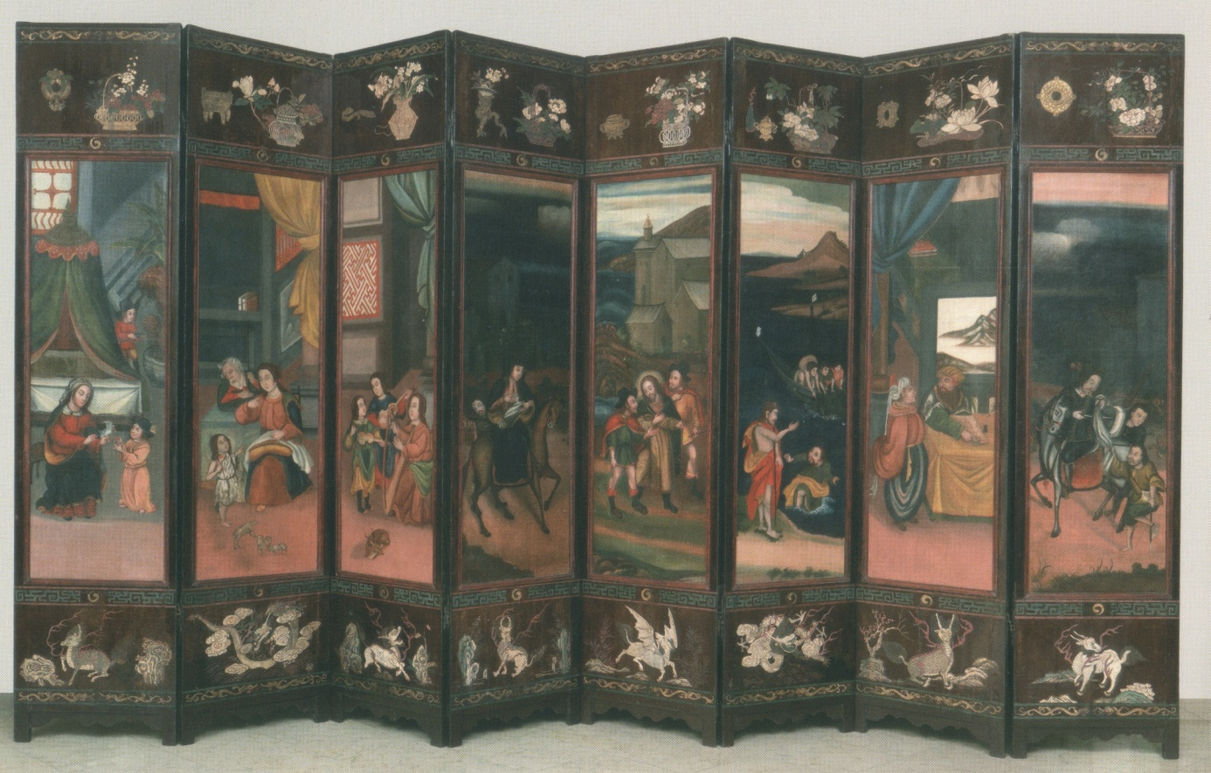In my article European Music in Japan in the 16th and 17th centuries I presented pictures of the vihuelas and lutes on so-called namban byōbu, painted screens made in Japan around 1600. These paintings were made after European originals, in a workshop set up by Jesuit priests, to satisfy the demand of European works of art in Japan. The similarity between the vihuelas on these paintings suggests there was one original painting or drawing that served as the example. This possible original painting is missing, but I speculated the Jesuits might have taken it with them to Macao or Goa when they were forced to leave Japan in the first few decades of the 17th century. On a recent trip to look at namban-art in the Orient Museum in Lisbon, I found on display a Coromandel screen with Christian scenes (see pictures), among which is a scene of three musicians celebrating the birth of Christ. The scene is very similar to the ones on the Japanese screens, it even includes the harp we see in so many of the Japanese paintings, and the vihuela appears to be based on the same model, although some it’s details are hidden by the harp.
Coromandel screens were made in China for the European market. They were shipped from ports on India’s Coromandel Coast, hence their name. This particular screen is undated, but the catalogue says it’s from the 17th or 18th century. I quote from the catalogue: “The almost naïve design betrays the use of European models interpreted by Asian craftsmen (…) several figures and scenes are omitted, and there are changes in the biblical order of some scenes, as well as some pure inventions in others, suggesting that the artist was not necessarily Christian”. This would rule out the possibility of the screen having been made in a Jesuit workshop. Early Coromandel screens show a strong resemblance to namban-art from Japan, so it is quite likely that artists from Japan went to China or that Japanese works were available to Chinese artists. The likely link are of course the Portuguese tradesmen and the Jesuits priests. This still leaves open many possibilities of how our ‘Japanese’ vihuela exactly came to China, but it also teaches us to keep our eyes open for vihuelas in countries and centuries where we don’t expect them.
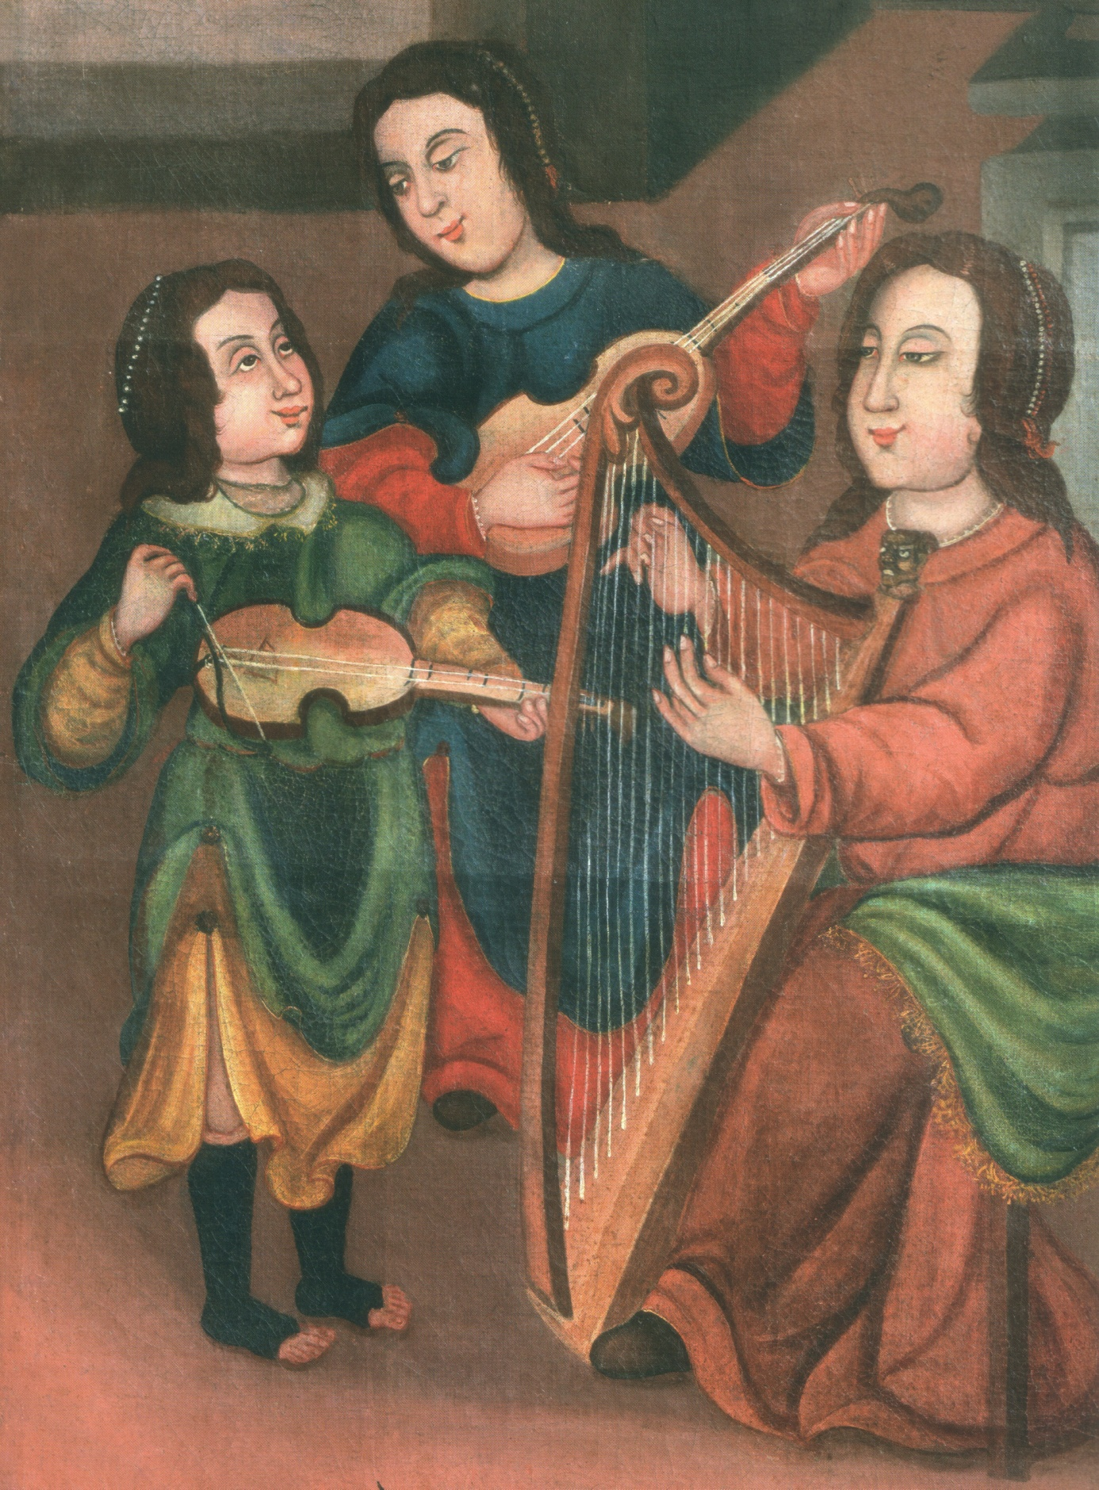

A. Curvelo et al: The Orient Museum, Lisbon (Fundação Oriente, undated catalogue).

