Fomrhi Comm. 1966 David Dolata

Castaldi’s Practice Room: Onomatopoeic Echoes (after Comms 1932, 1947)

Poet, singer, and theorbo virtuoso Bellerofonte Castaldi (1580–1649) spent the late 1630s at his family’s estate, the Casino Bianco, on the banks of the Panaro River in the tranquil village of Collegara in the countryside southeast of Modena. The Casino Bianco had become a refuge of sorts for Castaldi; he would regularly return to the family homestead between his various residencies and adventures in Rome, Naples, Sicily, and Venice to rest and re-energize. There at the Casino Bianco where his neighbors allowed him to “live in peace, where the stars by the millions appear at night, and where the days are delightful, long, bright, and serene.” During this period he transcribed the portion of his poems and versed correspondence that would become his Rime Burlesche, which included a poetic tour through his home at Collegara—the view from the windows, the vegetable garden, pasture, fields, the sound of the Panaro murmuring in the background, the rooms where he kept his books and paintings, and his practice room that he described as “an attractive and nice little room where his theorboes echo and echo.”
At times Castaldi was enveloped by echoes of the past, both near and distant, that he expressed in his poetic ruminations and echoes of the present that he transcribed as poetic dialogues. The musical echo, of course, became somewhat of a genre unto itself. Castaldi’s two-part madrigal “Echo” that appears in Modena Biblioteca Estense Mus.G.239 is a particularly extraordinary example for its stunning vocal fireworks, the rhetorical irony of its text, and its clever word-play. See Example 1.

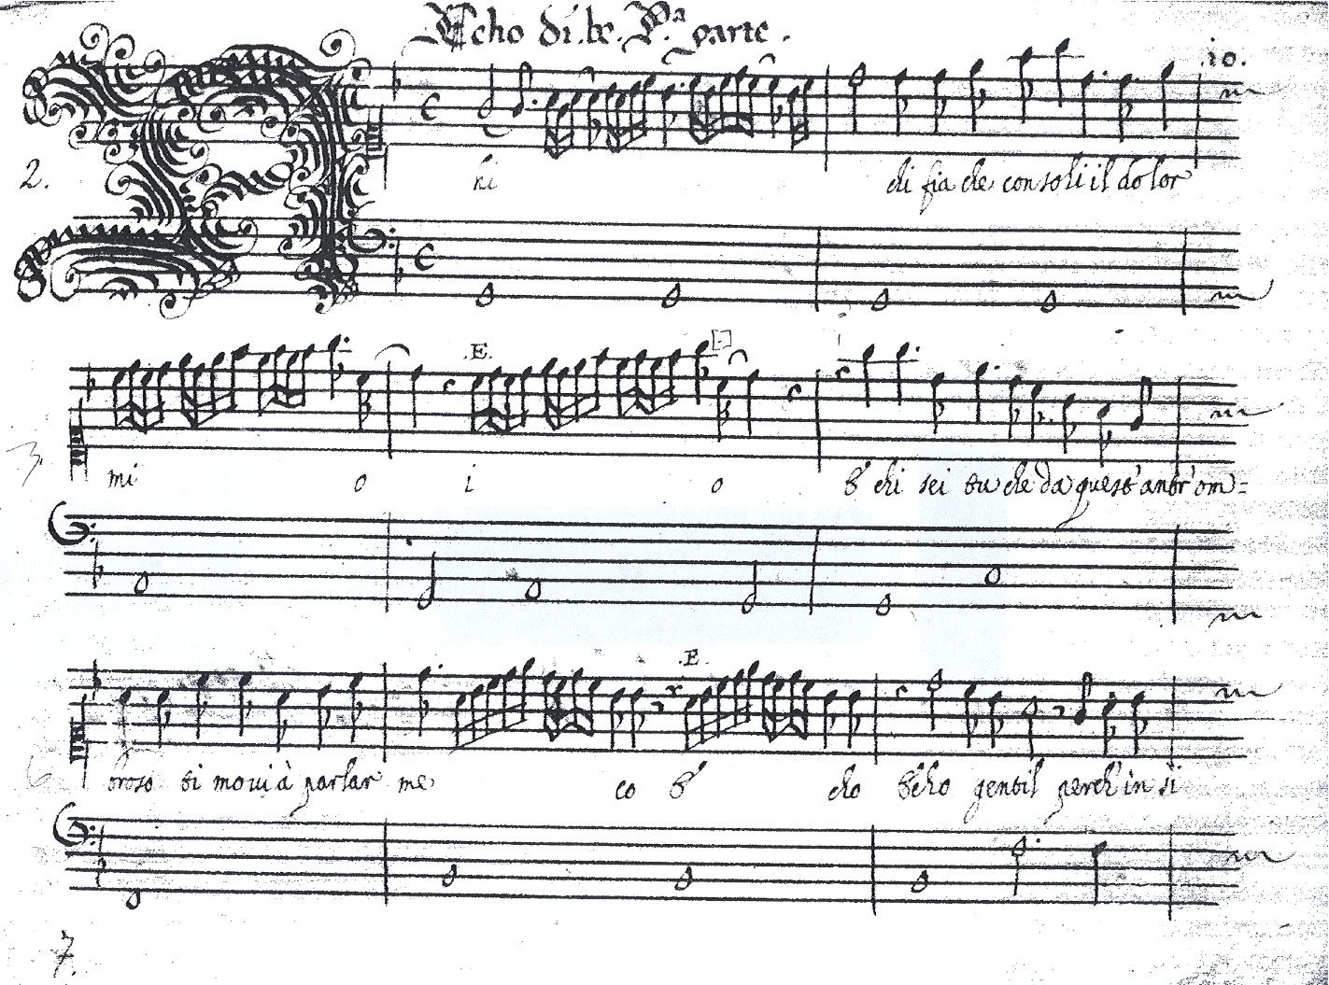

Example 1, Bellerofonte Castaldi “Echo,” Modena Biblioteca Estense Mus.G.239

“Echo” portrays a desperate lover who finds himself consoled, advised, and prompted by the fabled mythological figure of Echo, who by voicing the tormented lover’s own doubts and fears, brings them to the surface where he can confront them. In the second parte, the defeatist second Echo sadly overwhelms the singer’s hopes for a positive conclusion to his amorous plight, ultimately convincing him that the only possible solution is death. For a recording of this piece I refer you to Il Furioso’s recording “Battaglia d’amore: Castaldi’s settings of his own poetry” (Toccata Classics 0081, 2009).

Two of the dialogues in Rime Burlesche include instances of Castaldi’s use of onomatopoeic words to represent his tuning and then playing the theorbo, the significance of which, I realized only after reading Chris Goodwin’s article, “Tronc, tonc, tonc, preng, preng, preng: parole onomatopeiche come indicazione del suono e della tecnica esecutiva degli antichi strumenti a pizzico” in Il Liuto: Rivista della Società del Liuto 2 (2011): 30–37. This engaging article classifies the possible sounds represented by onomatopoeic words as applied to plucked instruments, drilling down to which consonants might indicate gut or metallic strings, plucking or strumming, etc.
The first dialogue is short, light-hearted, and titled simply “In dialogo.” In it, Castaldi describes opening a book of music, picking up the theorbo, and preparing to play “il ballo di Fiorenza,” but first he must tune:

- Eccola, ma convien prima accordarla
Cr, cri, già le sei corde sono unite
E i contrabassi pur sono al suo loco.
- Buono strumento da sé stesso parla.
-Tron, tron, com’è sonoro, che ne dite?

[- Here it is (the theorbo), but I should tune it first
Cr, cri, already the six strings are in tune
And even the contrabasses are set.
- A fine instrument that speaks of its own accord.
- Tron, tron, how resonant it is, what do you say?]

From this little excerpt we learn that Castaldi strung his theorbo in single courses and that there were six strings on the fingerboard and eight contrabasses, conclusions that are confirmed by the well-known self-portrait that appears in Capricci a due stromenti (1622) and Primo mazzetto (1623). “Cr, cri” sounds to me very much like the “creak” sticky tuning pegs can make when tuning. Additional evidence that Castaldi might be using these onomatopoeic words to represent tuning is that they appear in the stanza immediately after he decides to tune, and right after the “Cr, cri,” he declares that the instrument is now in tune. Note how each word sound contributes to the eleven-syllable lines and the stanza’s musical cadence.
“Tron, tron” is very close to the “Tronc” and “thrum” that Goodwin describes in great etymological detail. According to Goodwin, the currently accepted use of the term “strum” did not occur prior to the eighteenth century. In Castaldi’s dialogue, I take “Tron, tron” to represent the plucking of a string with the thumb, most likely a contrabass, because the verb “tronare” is an archaic version of the verb “tuonare,” to thunder or to boom. I would suspect that most of us who play theorbo have delighted in the resonance of our contrabasses and asked our friends, “What do you think?” after plucking a few notes. I know I have.
Castaldi’s second dialogue, “A l’improviso ottave in dialogo fatte del 1636,” is much longer and darker. It originally consisted of forty-four stanzas in ottava rima, however, twenty-eight stanzas are missing, and portions of many of the remaining stanzas have been crossed out to the point of illegibility. The bitterness, political satire, and occasional vulgarity that remain in the dialogue suggest that the purpose of the erasures by a later hand may have been to excise the more extreme expressions of Castaldi’s vitriol. Castaldi begins by bemoaning the fact that he is alone and asks himself why this might be. He broods over personal slights and a wide range of other grievances, but eventually in the 36th stanza, it occurs to him that playing a little might cheer him up. This time he picks up his tiorbino, a miniature theorbo that he himself invented. In Capricci’s dedication, Castaldi provided an entertaining and metaphorical description of the tiorbino’s birth. For a translation and commentary on the dedication see my article, “Visual and Poetic Allegory in Bellerofonte Castaldi’s Extraordinary Capricci a due stromenti,” Early Music XXXIII/3 (August 2005): 371-91. The nine virtuosic theorbo and tiorbino duos that he published in the aforementioned Capricci are the only known compositions that specify the tiorbino. Again, I refer you to the Il Furioso CD for recorded examples of several of these duos.
In the dialogue’s 37th stanza, he begins tuning the tiorbino, which is described in practically the same terms as in the above example:

- Tron, tron, bisogna ch’io l’accordi un poco
Crì, crì, già le sei corde sono unite
E i contrabassi pur sono al suo loco.

The only difference here is that he plucks a couple of notes, which tells him that he needs to tune. Later in the stanza, he announces that he’s starting to play:

Ora incomincio. Tirin tron, Crudele,

and so on continuing his litany of woe. “Tirin tron” sounds to me like two treble strings plucked successively by the fingers followed by one with the thumb.
Throughout the next stanza, Castaldi continues to play here and there, while in his mind confronting a lover who has rejected him with accusations such as “You laugh at my misery and do me wrong,” “You want to see me ruined,” and “My love for you has nearly killed me,” and so on. In between these outbursts he noodles away: “Tron, tirintron,” “Tron, tron,” “Tron,” and “Tron tirin tron,” accurately capturing the typical reverie musicians experience while practicing as our attention wanders between the music and our thoughts. In Stanza 39, however, Castaldi realizes that he is too frustrated to continue playing and puts the tiorbino down. But all is not lost. After several more stanzas, one voice suggests to the other “we should take a walk and perhaps vent some more another time.” The other agrees that fresh air would do them both some good. And finally, the first voice says that before leaving they should have a drink for the sake of better chit-chat. I agree. Cheers!

Here I thank Barbara Hanning for sharing with me the draft of her forthcoming essay “Powerless Spirit: Echo on the Musical Stage of the Late Renaissance.”

