FoMRHI Comm. 1919 John Downing

A Comparison of Oud and Lute Geometries – A 16th C. Lute by Giovane Hieber.

In Comm 1911 the geometry of a late 19th C oud by the Al Arja brothers of Tripoli, Lebanon was shown to be a close match to that of a lute represented in the late 15th C carving of ‘Pythagoras with Lute’ in Ulm cathedral.
This Comm. attempts to compare the geometry of the Al Arja oud with that of the well known late 16th C lute by Giovane (Giovanni) Hieber in the Musee Instrumental Conservatoire Royal de Musique de Bruxelles – catalogue No. 1561. The proposed geometry that follows was developed using a full size drawing of the instrument made by Stephen Murphy in 1976 and is a close match allowing for some slight asymmetry of the original.

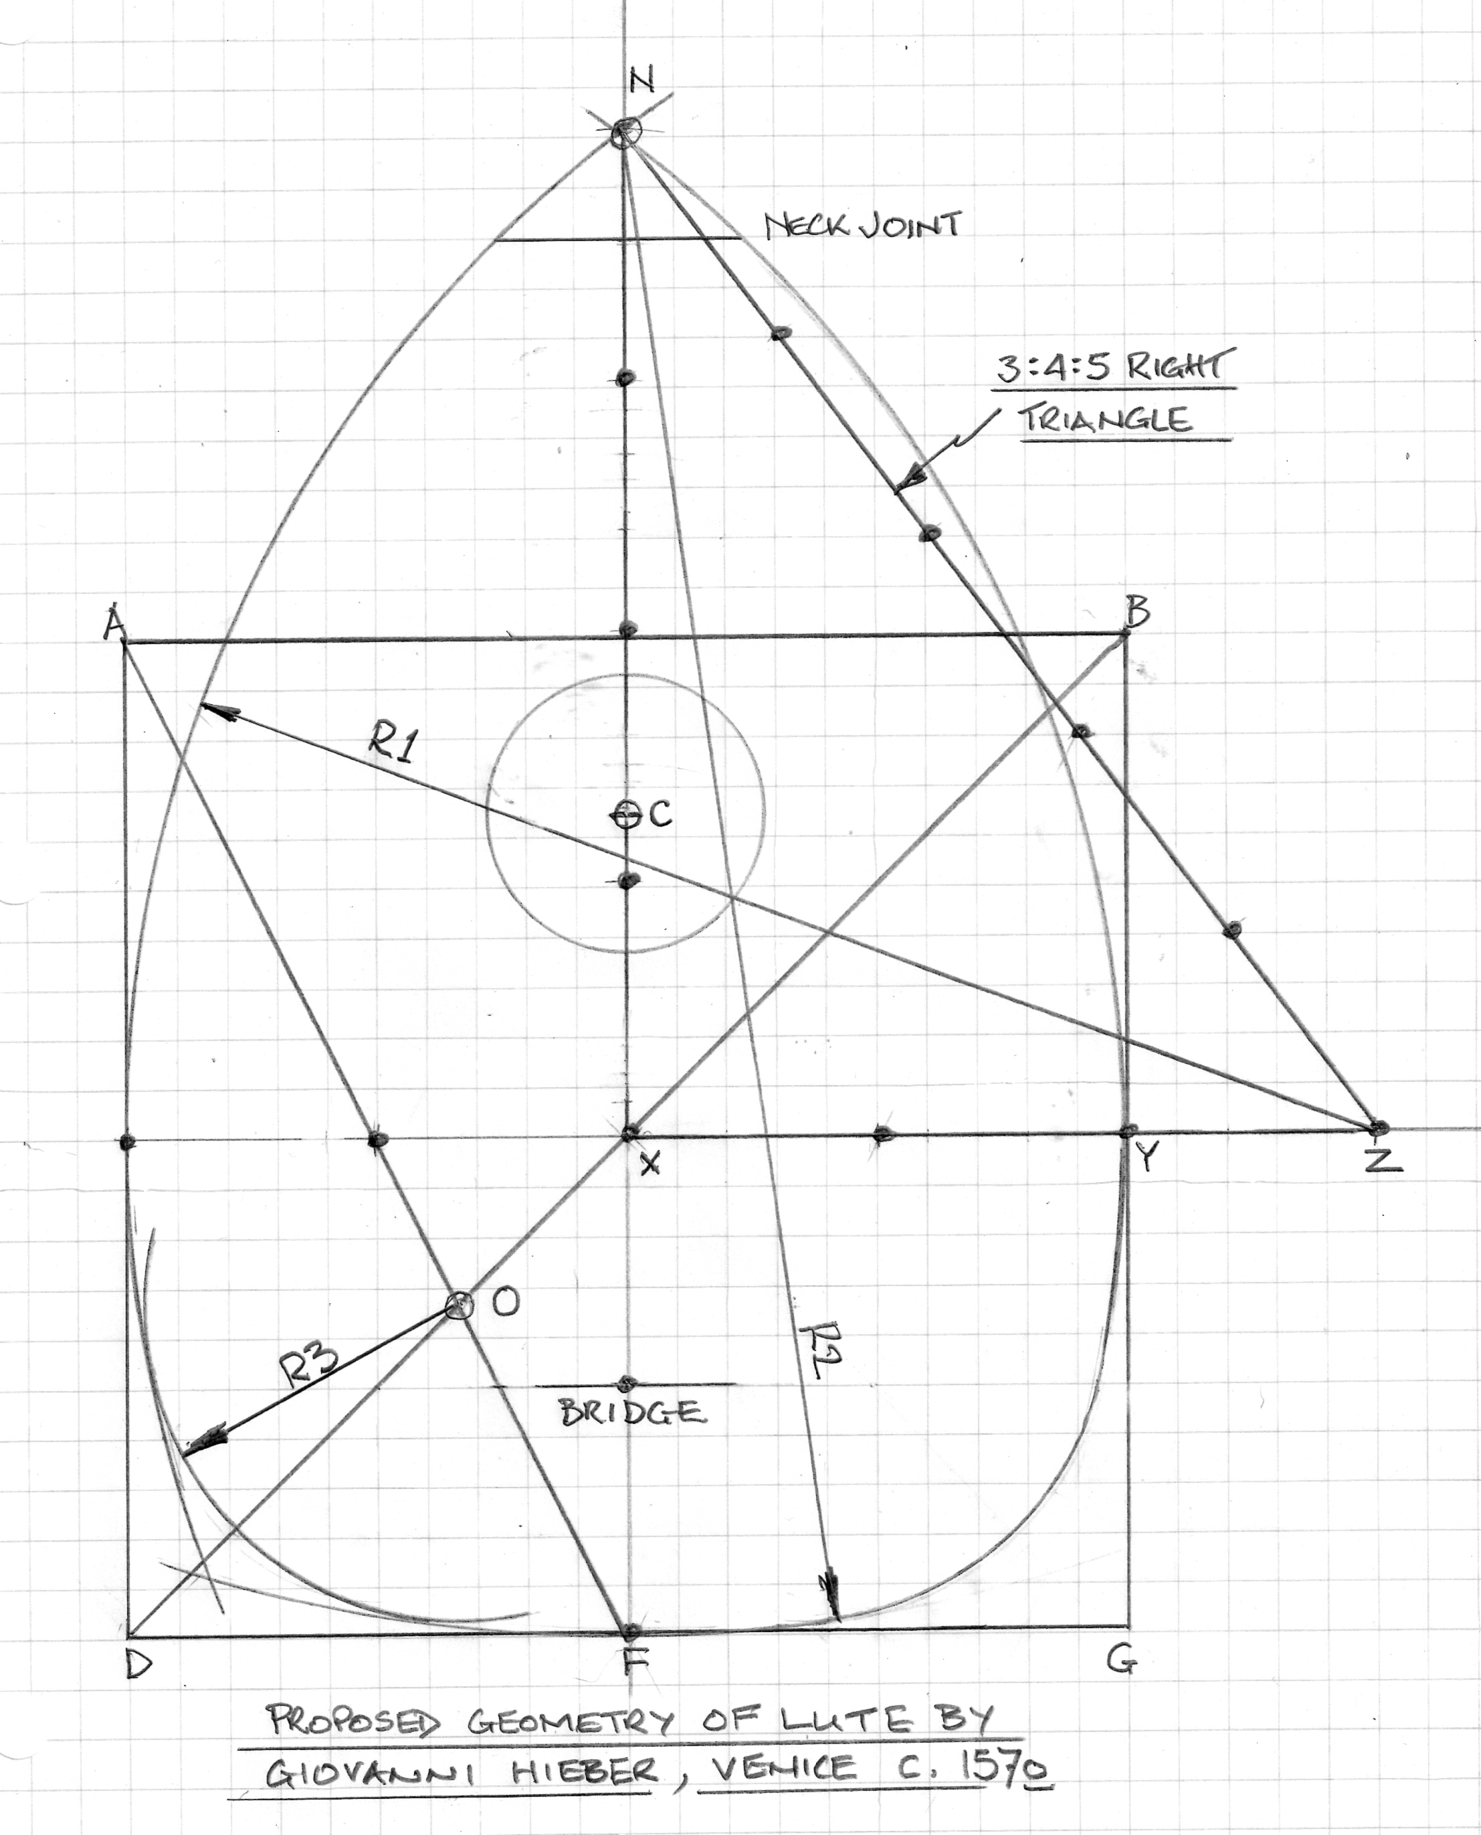
The geometry of the upper half of the sound board is identical to that of the Al Arja oud being based upon a 3:4:5 unit ‘Pythagorean’ right triangle XZN with the profile described by an arc of radius R1 (5 basic units) with center at Z. Sound board width is 4 units.
Again, as for the Al Arja oud, the front edge of the bridge is located one unit from X and the bottom of the sound board, F is 2 units from X.
Unlike the oud with its semicircular profile of the lower half of the sound board, the Hieber lute has a flattened shape generated as follows:
A square ABDG has sides equal in length to the sound board width (4 basic units). Diagonals AF and BD intersect at point O, center for an arc of radius R3 that just touches arcs traced by R1 and R2, blending in to create the required profile (which is not an ellipse).

Also, like the Al Arja oud, the neck joint position is dependant upon its width. In the case of the Hieber lute this is about 70 mm wide – just wide enough to accommodate 7 courses. The center of the sound hole C is then located midway between the neck joint and bridge – as for the oud.
This results in a slightly lower relative position for the Hieber sound hole as well as a slightly smaller sound hole diameter. The Hieber sound hole diameter is ¼ of the distance between the neck joint and bridge.

Note that Hieber, despite his Italianate name, was a luthier of German origin. Another suggestion perhaps of an earlier cultural connection between the German states (Holy Roman Empire) and countries of the Middle East?

