Fomrhi Comm 1982 Jan Bouterse

Dutch bassoons and rackets

At the end of the 17th century and throughout most of the 18th, the baroque bassoon was almost always referred to as basson in the Netherlands (and other countries). A confusing factor is that instruments called fagot already existed. In 1644 the Dutch town of 's-Hertogenbosch (Bar-le-Duc) invited applications for the job of tower watchman, the previous incumbent having died. The post went to Willem Tael from Wesel in Germany. Tael's credentials made him eminently suitable for the post; not only was he a member of the Reformed Church, he was also meesterlyck op de cornet, fluyt, fagot ende de andere instrumenten die geblaasen werden ( he was an excellent player of the cornet, flute (recorder), fagot and other wind instruments).*
* Municipal archives of 's-Hertogenbosch, Resolution A.59, April 23 1644.
Tael's 17th-century fagot was probably a dulcian (dulciaan), a common name in the 17th century and in general use today to denote this type of instrument. The term fagot may have been influenced by the German term Fagott used by Michael Praetorius to indicate the dulcian in his well-known Syntagma musicum from 1619 (vol. II, plate X).
Longer and perhaps later versions of the dulcian were also made in three sections; three-section instruments are in Vienna and Augsburg. For illustrations of these instruments see James Kopp ‘Notes on the bassoon in seventeenth-century France’, in: Journal of the American Musical Instrument Society 17 (1991), p. 85-114, based on drawings by Aranley and Lyndon Jones of 1983.

In the late 17th century the name fagot was still current, witness an advertisement placed in the Amsterdam Courant by the widow and son of the recently deceased Jan Jurriaensz van Heerde. The advertisement stated that the workshop would continue to supply woodwind instruments on Linde-graft, ... in de Gekroonde Fagot. It is not known how long the house had borne this name, but the Gekroonde (crowned) Fagot may well have meant the old dulcian, not the new baroque instrument.
Basson (in some sources spelled bason) derives from the French term most commonly used at
the end of the 17th century until the end of the 18th to denote the four-section instrument known today (in Dutch) as the fagot (bassoon). One of the oldest references to the baroque bassoon is in Richard Haka's invoice of instruments which he sold to Sweden (1685). This invoice lists a four-section franse Esdoorenhout dulcian basson (French maplewood dulcian basson), which may simply have been the basson frequently named in other Dutch makers' advertisements, inventories and suchlike. It is also interesting to note that Haka's invoice lists a separate item: a kooper Es tot de dulcian basson (a brass 'Es' for the dulcian bassoon). This 'Es' was undoubtedly the long crook that Dutch bassoonists still refer to as an 'S' today.
Another Dutch woodwind maker, Michiel Parent (1663-1710), was advertising as Musicant en Meester van de Basson, Hobois en Fluyten (Michiel Parent, musician and master of the [in the following order] bassoon, oboe and flutes). His house was moreover called In de Vergulde Basson (in the gilded bassoon), suggesting a special affinity for the instrument, which he may also have played professionally.
In the German language area Basson is also used to indicate the bass size of instruments other
than those with double reeds. For example, Jakob Denner's well-known invoice of 1720 for 17
woodwind instruments delivered to the monastery in Göttweig lists a basson three times: among the oboes, the shawms and the recorders.* There are no indications that the term basson was similarly used in the Netherlands.
* Ekkehart Nickel: Der Holzblasinstrumentenbau in der freien Reichsstadt Nürnberg, p. 253 (1971).
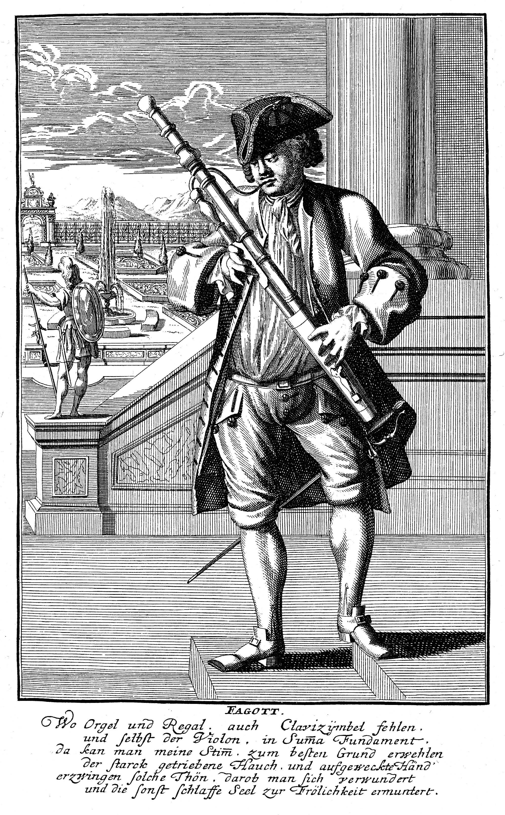
In Christoph Weigel's Musicales Theatrum (ca. 1720) there is an illustration of a bass recorder player whose instrument Weigel calls a Basson flûte. Incidentally, Weigel refers to the baroque basson as Fagott, not Basson. In 1961 Bärenreiter, Kassel, published a facsimile edition of this book.
In 2006, I became a question from the Stedelijk Museum (City museum) in Zwolle, that there was an instrument in the collection which was called a bassonfluit. After inspection it became clear that this was a baroque bassoon, made by Coenraad Rijkel (1642/1646-1726). This instrument had been played until late in the 18th century by the Patriottisch Vollenhoovsch Exercitie Genootschap, on of the several rebellious groups who were active in the Netherlands and who were defeated in 1787 by the Prussian armee. The bassoon survived only because of an inscription, which was written on the brass mounts of the instrument, in Dutch and Latin warning against the rebels (patriotten).*
* Ik moest den waapen-kreet der Patriotten blaasen, Ao. 1785; Nu heb ik uitgedient, en toon het lot dier dwaasen, Ao. 1787. Pro ARIS et FOCIS falso cantamine Plebem decipiendo decepti, exarmati 1787 ['Pro ARIS et FOCIS' was the heraldic device of the patriotten).

Halfway through the 18th century the word fagot reappears. An advertisement in the Oprechte
Haerlemse Courant of Thursday May 17th 1759 announced that the Wed. Adriaan Moetjens,
Boekverkoopster in 's Hage, zal op Woensdag, den 30. Mey, 1759 [...] publicq verkoopen
[...] een groote Party allerhande fraaye en kostbaare Instrumenten (waaronder klavecimbels
van Johannes Couchet en Andreas Ruckers), benevens [...] Bassons of Fagotten, Fluyten,
Hobois, Schalmeyen ..., alle nagelaten door den Heer Nicolas Selhof, Boekverkooper ... (on May 30, 1759, ... the widow of Adriaan Moetjens, bookseller at The Hague, will offer for public sale a large consignment of diverse handsome and costly instruments (including harpsichords by Johannes Couchet and Andreas Ruckers), bassoons, flutes, oboes, shawms, all from the estate of Nicolas Selhof, bookseller).

In 1771 Jacob Wilhelm Lustig had (in his Inleiding tot de muziekkunde) the following to say about the bassoon: Basson (Dulcian of Fagotto), gaande van C tot g1, zelfs tot contra A, ... ... tot concerteerende stukken kunnen dienen (basson, dulcian ore fagotto, compass from C to g1 and even to A1, suitable ... ... also for concertante works.
The compass specified by Lustig corresponds with what in 1786 the unnamed author of the
treatise entitled Verhandeling over de muziek (Anon. 1786) wrote. On page 302 we read:
Fagotto, Basson: blaesinstrument, daer met een rietje de grontstem of bas voor de hautbois op wordt gespeeld, deszelfs laegste klank is B, doch door zacht blaezen gaen zommige tot A. (Fagotto, Basson: reed-blown wind instrument on which the bass-line for the oboe is played and whose lowest note is B, although blowing gently will even produce an A on some instruments.).
The Verhandeling over de Muziek goes on to describe the Dulcino briefly: Quart fagot, kleine
basson (quarter or small bassoon). Egbert Buys, in his Nieuw en volkomen woordenboek van
konsten en wetenschappen (Buys 1769-1778, Vol II, p. 64) describes the basson as follows:
Een Muziek Instrument daer met een Riet geblazen wordt, voorzien met 11 gaten, en gebruikt tot een Bas, in een Concert van Hautbois, Fluiten, enz. Om dit Instrument draagbaarder te maken, is het in twee (sic) Stukken verdeeld, waarom ment het ook een Fagot noemt. Deszelfs Middel-lijn is onderaan negen Duim, en de Gaten worden gestopt gelijk die van een groote Fluit. (A reed-blown musical instrument drilled with 11 holes and used as a bass in a consort of oboes, flutes, etc. To make this instrument easier to carry, it is divided into two [sic] pieces, which is why it is also called a Fagot. Its diameter is nine inches at the bottom, and the holes are stopped like a big flute's).
Buys' description is rather odd, because it states the number of holes but not the number of keys (eleven is only correct if the instrument has a g-sharp key hole), and because of his definition of the term fagot.

A distinction of a completely different nature is drawn between the basson and fagot; it is foundin 1795 in the Muzijkaal kunst-woordenboek by Verschuere Reynvaan, who devotes two
entries to the basson. In the first one, under basson or bassone and bassono, he describes the
(old) four-keyed type, and in the second, under fagot, he introduces the (newer) model with six keys. This is a sign that basson was a generally accepted designation for the traditional baroque bassons, and that with the appearance of new instruments at the end of the 18th century, fagot came back into use.

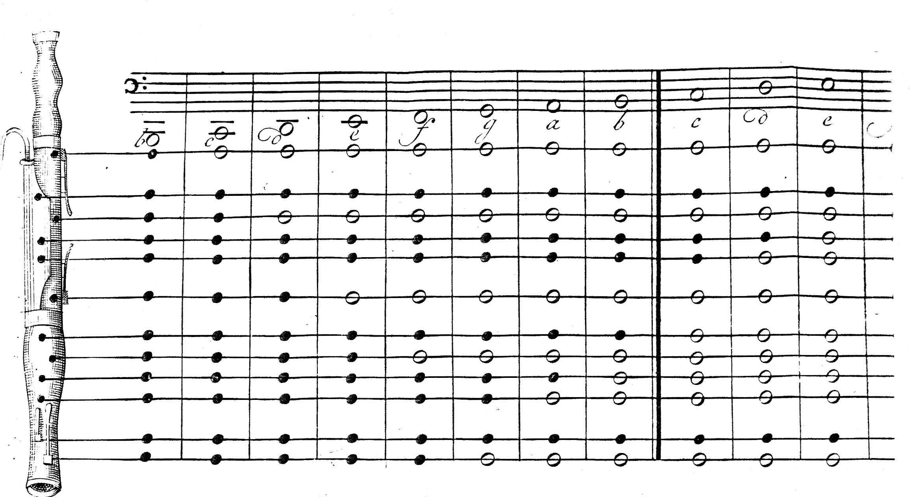

Part of the fingering table by Verschuere Reynvaan for the basson with four keys

Verschuere Reynvaan also refers briefly to the two-keyed basson (the bombardo) and the three-keyed instrument, both of which he discusses under vulgo dulcian. In the fagot entry we read: Aangaande de hooge g, indien de Basson een sleutel heeft aan het kopere stuk, de Bocaal of zogenaamd slang alwaar het mondstuk op gezet wordt, behoeft men de kleine sleutel niet te openen; welke tusschen de twee groote sleutels in het midden is. (With regard to the high g, if the bassoon has a key on the brass part, the bocal or so-called crook attached to the mouthpiece, the small key between the two large keys in the middle need not be opened.
This is a puzzling sentence. What does Verschuere Reynvaan mean by the keys (as many as three of them) on the bocal? Not until fifty years later did it become customary to have an overblow hole on this bocal (the 'S' or 'Es'), which still later was fitted with a key.
See Dullat: Holzblasinstrumentenbau, Entwicklungsstufen und Technologien. Celle 1990 (Edition Moeck No. 4040), p. 116. This overblown key hole may not be confused with the pinhole, a small hole drilled by modern players at the bottom of the (wider) section of the S on baroque bassoons (and which can therefore not be closed with a key) for the purpose of facilitating the speaking of a few 'awkward' tones without placing the speaking and sound of other, 'easy', tones at too much of a disadvantage. However, the author does not know whether such pinholes were used in the first half of the 18th century.
Incidentally, Verschuere Reynvaan was perfectly right to state the bassoon's lowest tone as B-flat.

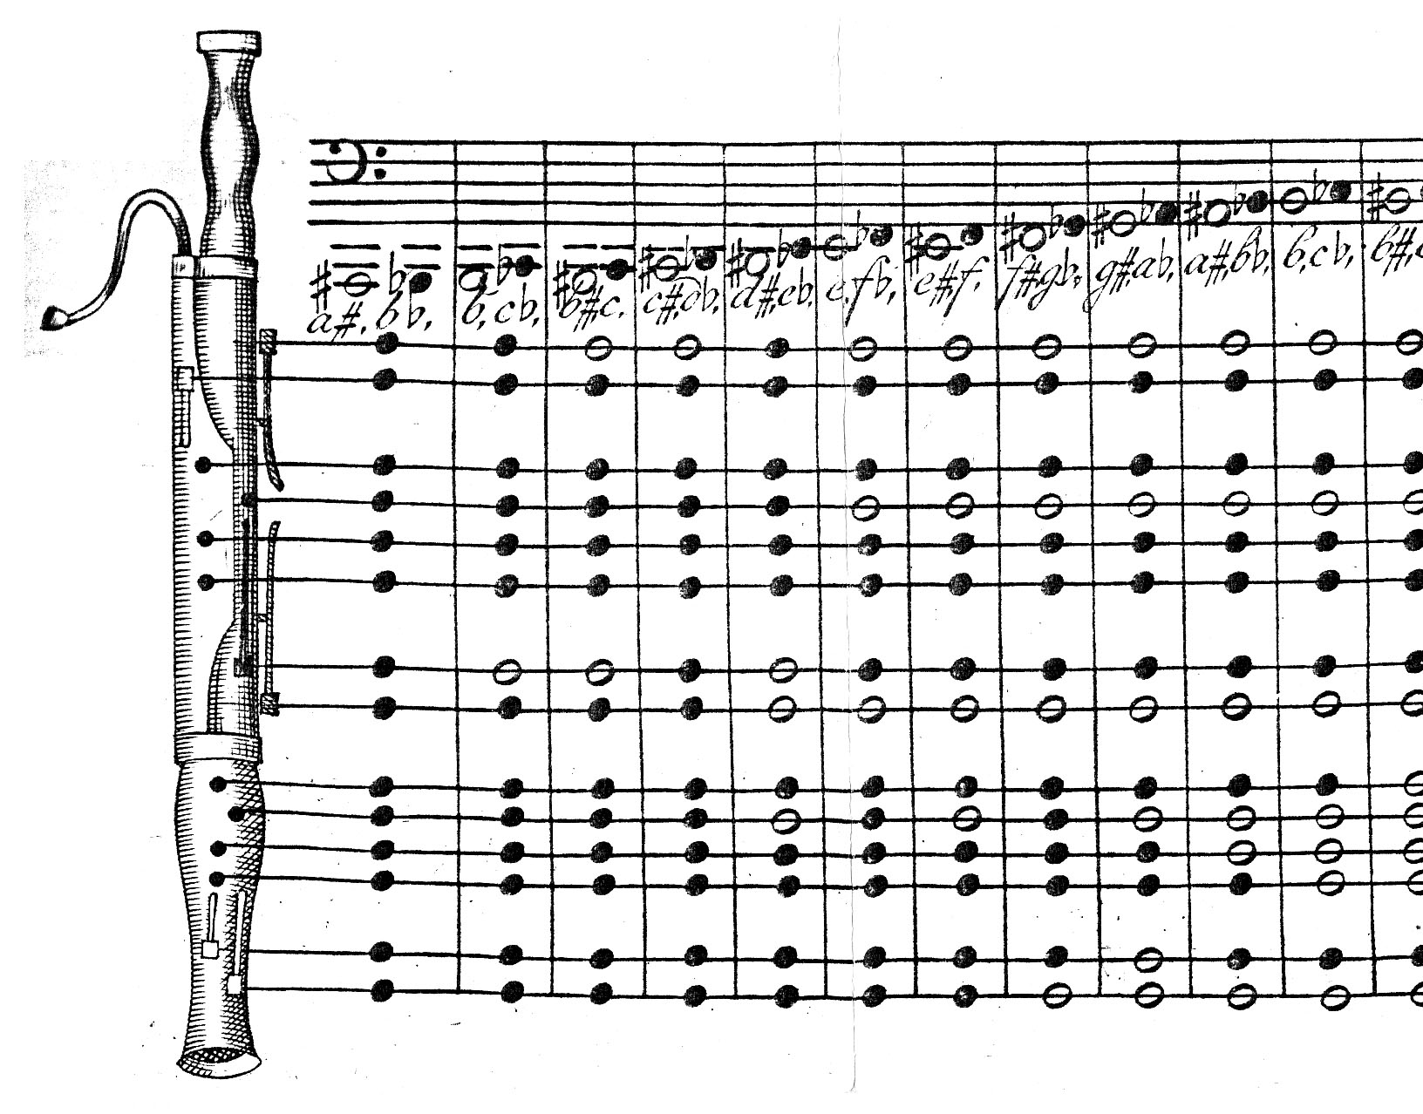
Part of the fingering table by Verschuere Reynvaan for the fagot with eight keys

Joos (or Joost) Verschuere Reynvaan was a lawyer in Vlissingen. Only part 1 (A-M) of his Muzijkaal kunst-woordenboek (musical art dictionary) was published, but surprisingly almost all woodwind instruments of his time are included.

The racketts

Of all woodwind instruments, the rackett or cervelas is the champion of the 'folded bore'. The
baroque rackett, of which few examples survive outside the Netherlands, was probably invented by Johann Christoph Denner of Nuremberg (1655-1707); later ones are by French makers such as Bizey. A rackett by Charles Bizey, who worked in Paris between 1716 and 1752, was in the sale of Early Musical Instruments at Sotheby's, London, in December 1997. This instrument, a picture of which is on p. 45 of the catalogue, is basically along the lines of the two surviving Dutch racketts, but the turning is more pronounced. Other racketts by Bizey are in the Musée de la Musique in Paris and the Münchner Stadmuseum in Munich.

The baroque instruments differ from earlier Renaissance racketts in their bores, which widen conically from the passage onward as far as the bell, where the bore, in keeping with most baroque bassoons, tapers again. The crooks on the baroque racketts are so long that their
makers coiled them; in the Renaissance instruments a short staple is enclosed in a pirouette.

We know of two extant baroque racketts that were made in or related to the Netherlands: by Willem Wijne (Berlin) and the instrument that was in the Haags Gemeentemuseum (inv. no. Ea 65-x-1952) and is now back in the (depot) of the Rijksmuseum in Amsterdam. The latter is unstamped, but is enigmatically inscribed PYP 4 MAAL (pipe 4 times?). This inscription is unlikely to refer to the number of bores in the rackett (i.e. 2 x 5), nor to its range, for this is an eight-foot instrument. Its meaning must remain a mystery.
I have not found any reports of worstfagot or rackett in advertisements, inventories of records of the instruments in the books I mentioned before in relation to the bassoons.

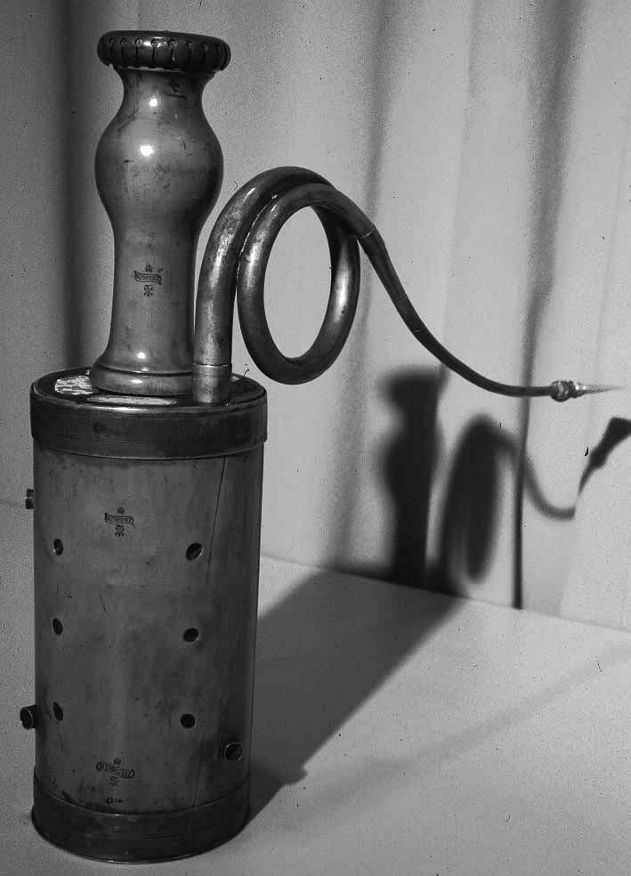

The rackett by Willem Wijne in Berlin, in the museum with the long name: Musikinstrumentenmuseum des Staatlichen Instituts für Musikforschung Preussischer Kulturbesitz.

Production and number of extant Dutch bassoons and racketts
Fourteen Dutch woodwind instrument makers from the period between 1660 and 1780 are known to have made, sold, played or owned bassoons. Those makers are from Amsterdam: Haka, Jan de Jager, Parent, Rijkel, Thomas and Jan Boekhout, Van Aardenberg, Nieuwenhoven, Van Heerde, Terton, Van Driel, Hendrik Richters and Robbert and Willem Wijne (Nijmegen) and Johannes Van de Knikker (Tilburg). However, only four bassoons and two racketts by Dutch makers have been traced; the stamps on them are those of Haka, Rijkel, Willem Wijne and Van de Knikker. This meagre harvest of bassoons is in stark contrast with the more than a hundred extant Dutch oboes and shawms. (by 22 makers). It is difficult to account for so few survivors, considering that the very size of a bassoon makes it hard to lose.
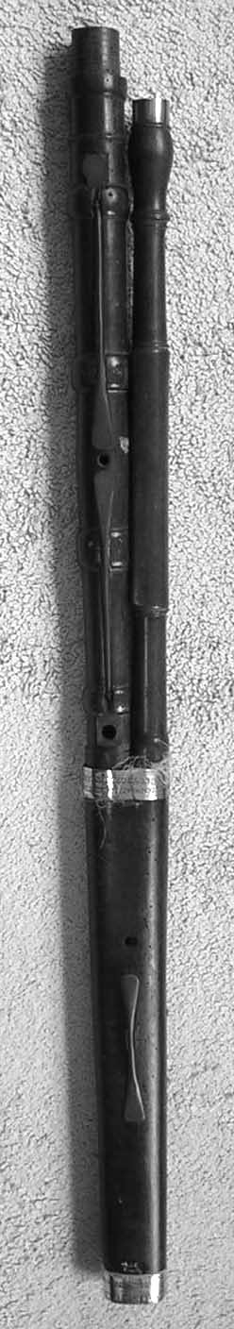
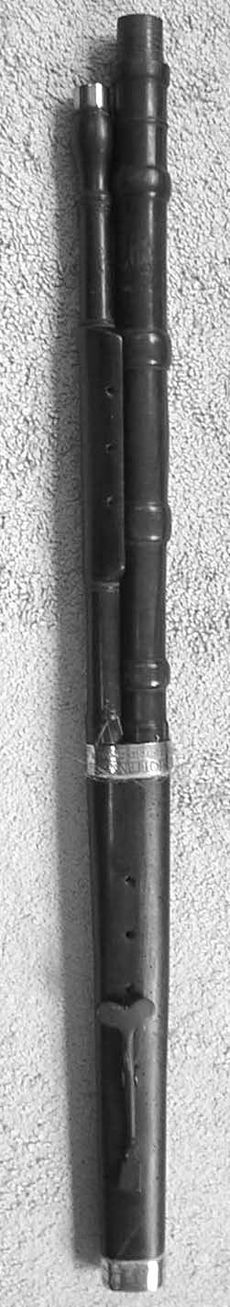
During conversations with other researchers and players, someone advanced the theory that more bassoons than other instruments were played by professional musicians and that these bassoons were played until they were completely worn-out and then thrown away. But perhaps the explanation is that fewer bassoons left the workshops. Why?
Simply because they are not the easiest instruments to make and because they require a different technique from the one used for making an oboe or a recorder. For instance, a bassoon has fewer turned joints and sections but requires a lot more cutting and planing. Furthermore, the insertion of two slightly converging bores into the butt joint is no simple matter. The same applies to the drilling of the long, slanting fingerholes in the wing joint and to making the long, curved crook to which the double reed is attached.

Front and backside of the bassoon by Rijkel in Zwolle. The bell of the instrument, which is not original, is not on the photo.
There is no g#-key at the front of the boot, but instead there is a key (original?) at the back boot, maybe for playing the g#.

This article is an adaption of a part of the dissertation Dutch woodwind instruments and their makers, 1660-1760 by Jan Bouterse. The dissertation was published in 2005 by the KVNM in Utrecht.
See http://www.kvnm.nl/webshop/ for more information.

