FoMRHI Comm 1946 M. van der Most

Volumes of differend kinds of double reeds

The bore of conical double reed instruments as baroque oboe, baroque basssoon, bass, tenor, alto and soprano curtal is formed as a truncated cone. This is necessary for connecting the reed to the bore.
The length of the instrument as used for calculations is that cone without truncating, meaning the cone to its top. The volume of the reed has to be about the volume of the truncated part. See literature.

You can't calculate the volume af a double reed as it is not possible to measure the complicated form of the reed with any form of accuracy.
For a laboratory worker like the author, with much experience on pipetting, it is rather simple to fill a reed with water from a measuring pipette. This has a scale divided in 0,01 ml = 10 μl.
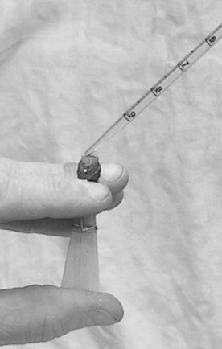
Figure 1

The reed is soaked in water for some minutes (real time). Adhering water is shaken off and the reed is blown dry. Then it is closed with the thumb and filled with water from a measuring pipette of 1 ml. See fig. 1. After some try-outs three consecutive measurements are made and the average is calculated. This is done with the reeds of baroque bassoon (a=415 Hz), baroque oboe (a= 415 Hz), bass, tenor and alto curtal (a=440 Hz)

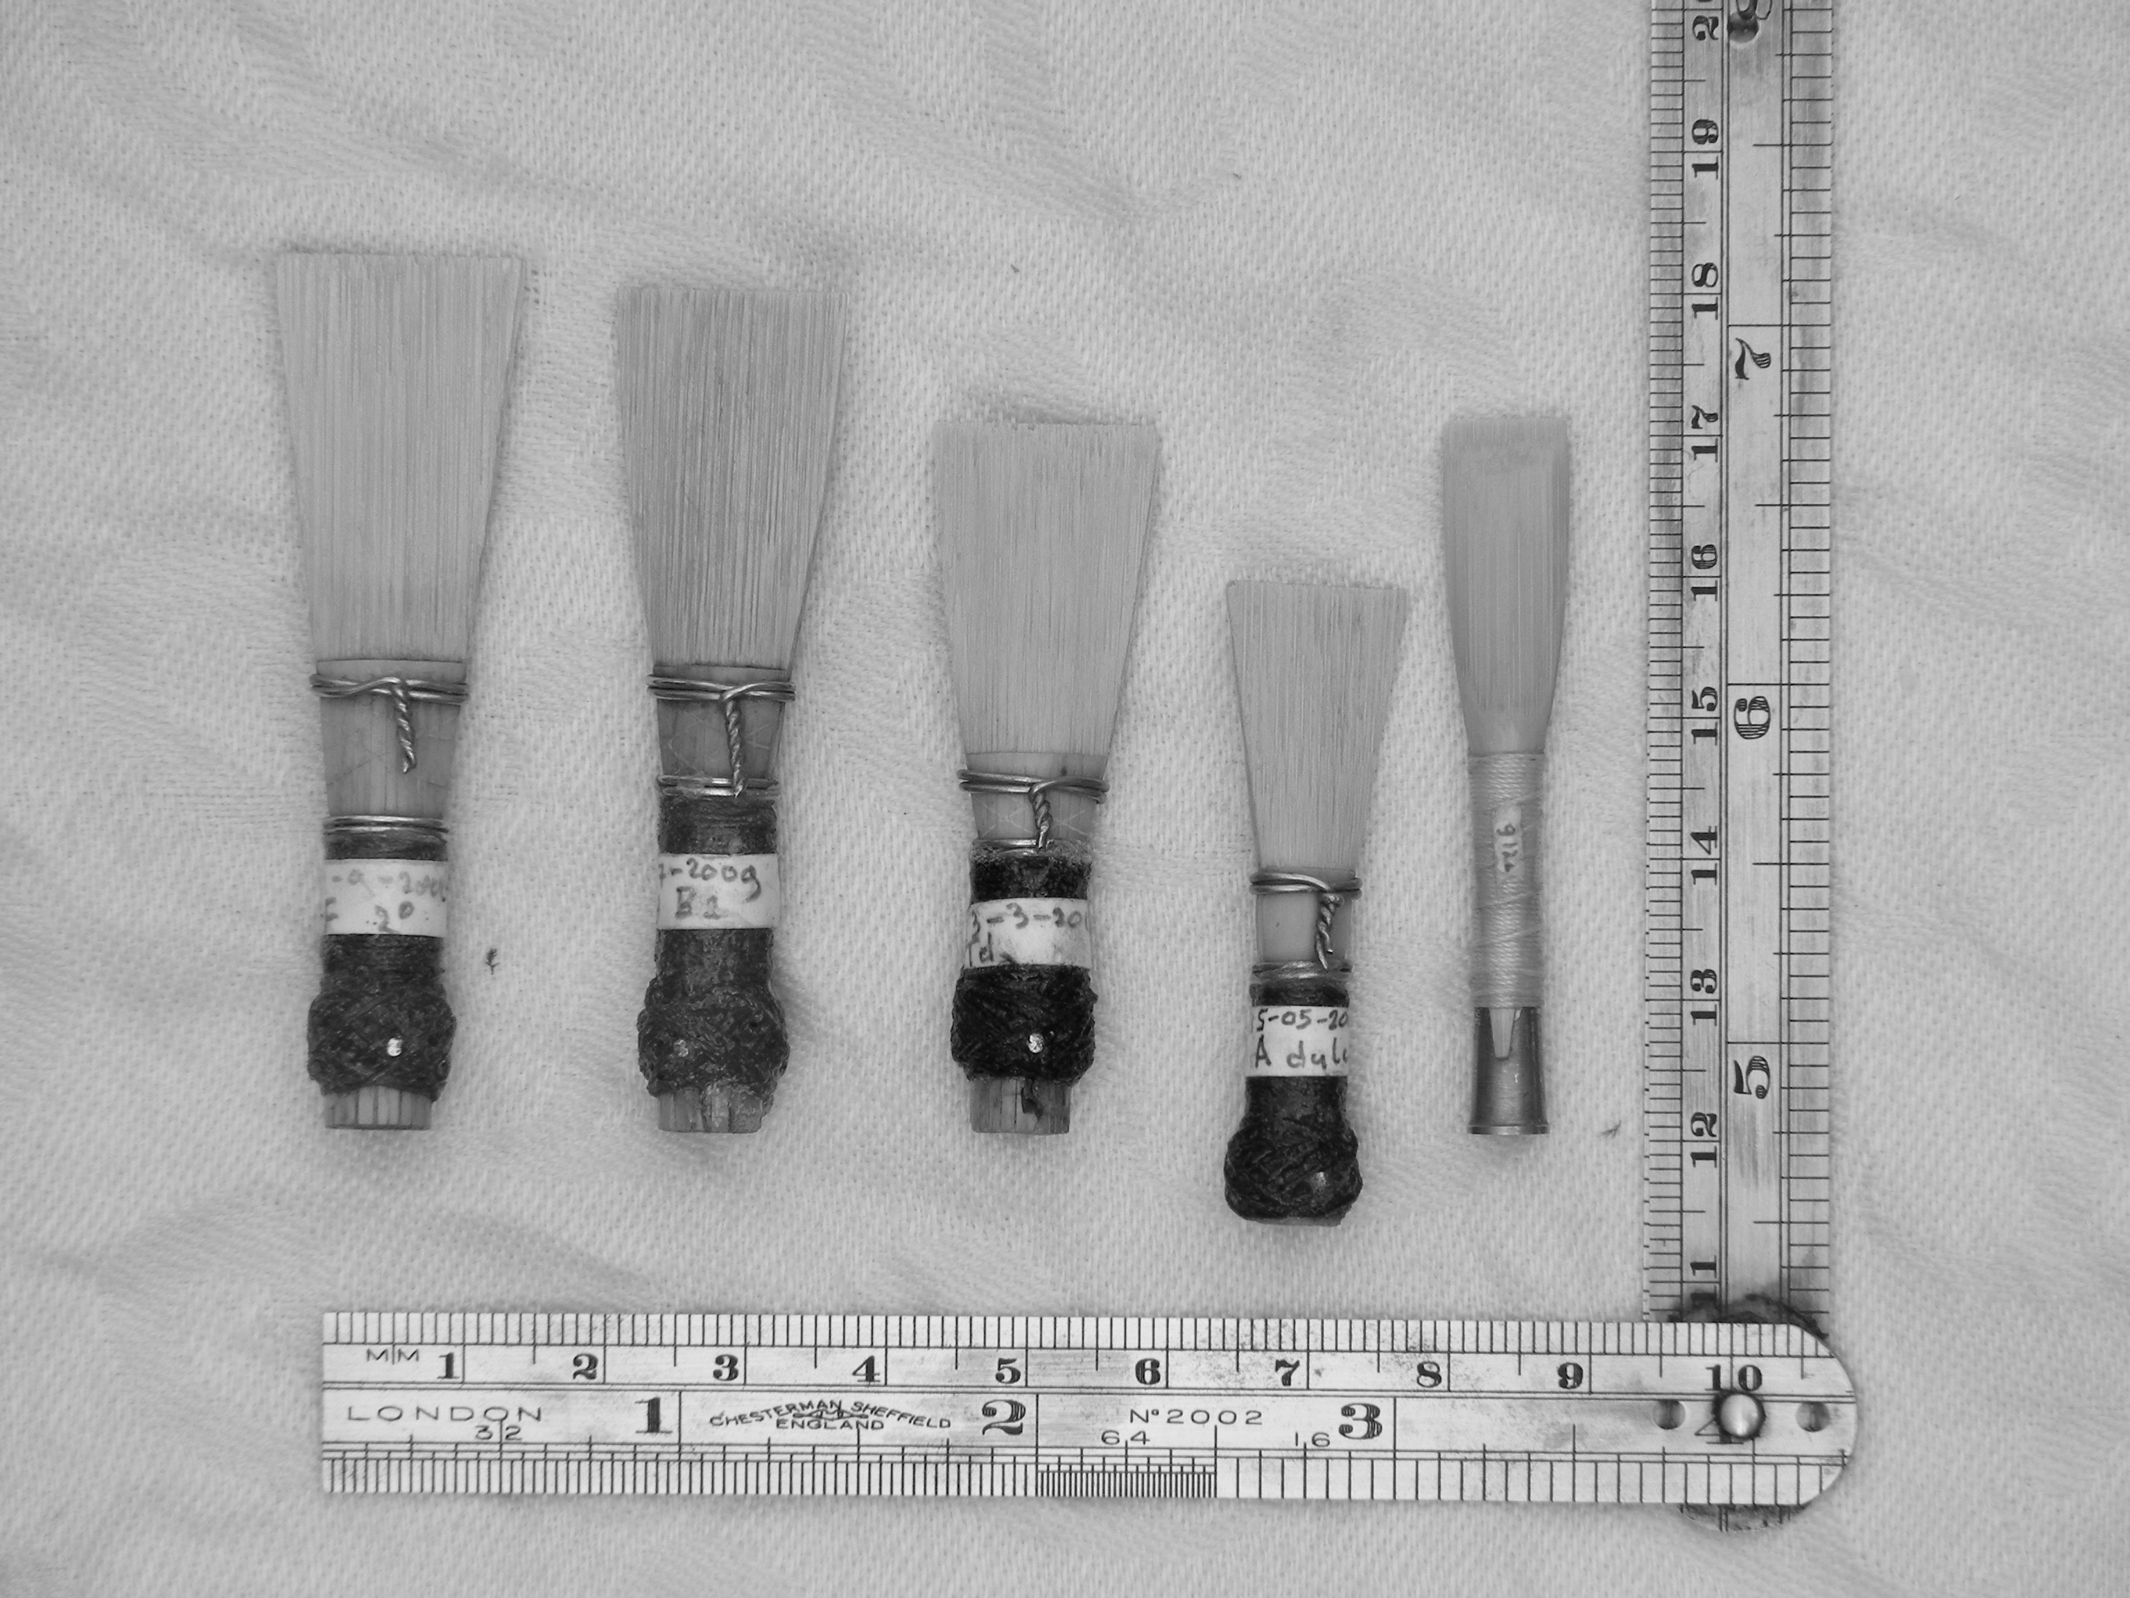

Figure 2

The reeds are pictured in fig.2. From left to right: reed for baroque bassoon, bass, tenor and alto curtal, baroque oboe. The reed for bassoon and curtal slips over the crook for about 6mm, exept that of the alto curtal, which slips over for 10,5 mm. 5-6 mm is standard. The measured volumes of this reed are those of the original. Also are given the calculatd values for an alto reed shortened with 4,5 mm (10,5 - 6).That is why the alto reed in fig.2 is positioned 4,5 mm inferior to the other reeds.
The volume of the reed for baroque oboe is given inclusive the upper staple.

Table 1 Volumes of the reeds Values are rounded off to 10 μl

Baroque bassoon measured volumes 730/720/750 μl
average volume: 730 μl

bass curtal measured volumes: 790/790/800 μl
average volume: 790 μl

tenor curtal measured volumes: 550/560/550 μl
average volume: 550 μl

alto curtal measured volumes: 460/460/450 μl
(original) average volume: 460 μl

alto curtal measured volumes: 390/390/380 μl
(corrected) average volume: 390 μl

baroque oboe measured volumes: 490/480/480 μl
average volume: 480 μl

To optain the volume of the reed after placing it on the crook or under staple you must lessen its volume with the volume of the lenght over which the reed has slipped. The outside diameter of crook or staple is measured on half of this lenght. Its volume is calculated from the lenght of the whole part and the average diameter.

In table 2 I have noted these results for my crooks and staples. The deviation of the volumes with regard to other crooks and staples is to ignore in relation to the rounding up used in the measurements.

Table 2 volumes of the reed after placing on crook or staple

Baroque bassoon:
volume reed: 730 μl
slipping over crook: 6 mm; average diameter 5,2 mm; volume: 130 μl
net volume reed: 730-130 = 600 μl

Bass curtal:
volume reed: 790 μl
slipping over crook: 6 mm; average diameter 5,3 mm; volume: 130 μl
net volume reed: 790-130 = 660 μl

Tenor curtal:
volume reed: 550 μl
slipping over crook: 6 mm; average diameter 4,6 mm; volume: 100 μl
net volume reed: 550-100 = 450 μl

Alto curtal as measured:
volume reed: 460 μl
slipping over crook:10,5mm; average diameter 4,4mm; volume: 160 μl
net volume reed: 460-160 = 300 μl

Alto curtal as corrected:
volume reed: 390 μl
slipping over crook: 6 mm; average diameter 4,4mm; volume: 90 μl
net volume reed: 390-90 = 300 μl

Baroque oboe:
volume reed: 480 μl
slipping over staple: 8,2 mm; average diameter 4,6 mm; volume 125 μl
net volume reed: 480 - 125 = 355 μl

Literature

Nederveen: ‘Berekeningen aan houtblaasinstrumenten’ (Calculations on woodwind instruments)
Bouwbrief 50 1988 blz. 15

Nederveen: ‘Akoestiek van houtblaasinstrumenten’ (Acoustics of woodwind instruments)
Journaal van het Nederlands Akoestisch Genoodschap
nr 160 (2002) blz. 23

Steinkopf: ‘Zur Akustik der Blasinstrumente’ (About acoustics of windinstruments)
Moeck nr. 4029 (1983) blz. 38

